Swarland Avenue Surgery

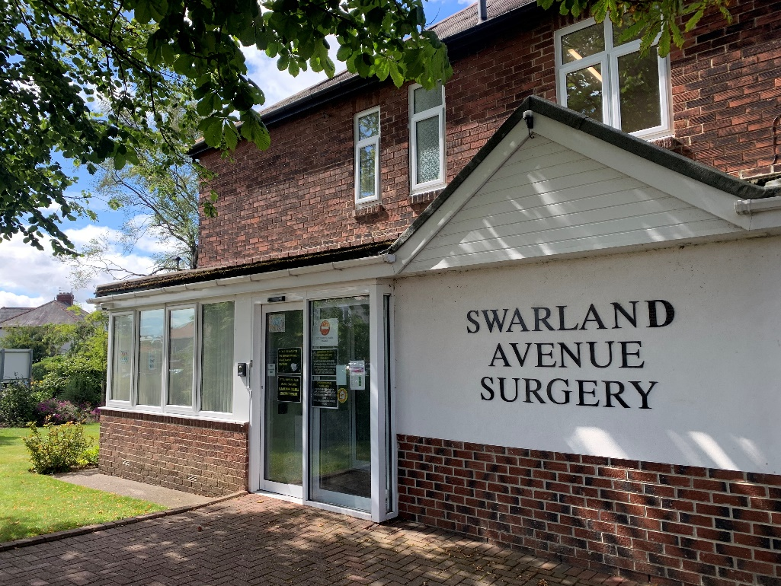

2 Swarland Avenue
Benton
Newcastle upon Tyne
NE7 7TD

0191 215 0141
www.swarlandavenuesurgery.nhs.uk

Opening Hours

Monday 8:30am – 6:00pm
Tuesday 8:30am – 6:00pm
Wednesday 8:30am – 6:00pm
Thursday 7:30am – 6:00pm
Friday 7:00am – 6:00pm

(Closed between 1:00pm – 2:00pm)

GP Partners

Dr Clare Mears - Senior GP Partner (Female) Special interests: Sexual Health, GMC No. 4013884

Dr Naeem Iqbal - GP Partner (Male) Special interests: Diabetes, Minor surgery. Asthma. GMC No. 4563004

Dr Helen Dahl - GP Partner (Female) Special interests: Care of the elderly, Palliative care and Child Health. GMC No. 6106026

Salaried GP

Dr Ashleigh McDonald

Practice Manager

John Snaith

Beth Foster

How to Register
If you wish to register at the practice, please arrange to collect a registration pack or download the forms from the practice website. You may get invited to attend a new patient check depending on your medical history.

Making an appointment
Appointments can be booked by using online services (GP only) or by telephone. We aim to offer a routine appointment with a GP within 10-14 days. For same day urgent appointments please contact the surgery at 8.30am. You can make an appointment with a nurse practitioner without seeing the doctor first. Appointments at the surgery are available throughout the day Monday - Friday. We also operate a weekly early morning surgery between 7.00am – 8.00am for practice nurse and Health care assistant appointments only. We now also offer online consultations which can be accessed by visiting our practice website. We also utilise appointments offered via our local hub at the Oxford Centre, Longbenton where GP's and nurses are available all day.
The reception team may ask for a brief description of your issue, this is necessary to triage your appointment and book with the most appropriate clinician.

Wasted appointments
Missed appointments means that someone else has to wait longer to be seen. Please phone as soon as possible to let us know if you cannot attend your appointment. The practice may write to patients to remove them from the list if multiple DNA's (Did Not Attends) are identified.

Telephone advice/consultations
You may want to speak to a doctor or nurse, but don’t need a face-to-face appointment. There are limited appointments for telephone advice, and this can be arranged via reception staff.

Home visits
If you require a home visit, please contact the surgery before 11am (this is only for patients who are housebound). The doctor may speak to the patient over the phone before visiting or arrange for another health professional to see the patient if necessary. Please try and attend the surgery if possible (a doctor can see 3-5 patients at the surgery in the time it takes to visit one patient at home).

Out of hours
If you need an urgent appointment at the weekend, please ring: 0191 486 2195 to book an appointment in a local hub. If you require healthcare advice at any time, 24 hours a day, contact NHS 111, or visit www.nhs.uk. If you need to see a doctor urgently outside normal surgery opening hours, walk in centres are open from 8am to 8pm 7 days a week. Out of hours GP services are provided by qualified doctors and nurses. You may receive telephone advice from a doctor who can arrange attendance at a local primary care centre for an examination or for medical reasons where travel is impossible, a home visit can be arranged. You should only dial 999 for an ambulance in a life-threatening emergency or serious accident.

Repeat prescriptions
Prescriptions can be ordered by using Patient online access, by contacting the practice after 11.00am or presenting to reception. Your prescription can be sent electronically to a pharmacy of your choice. Prescriptions will be ready to collect within 48 hrs. Someone else can collect for you if they are over 16 and show your ID (With the exception of controlled drugs). If you are collecting a controlled drug, ID will be required at the point of collection.
We try to encourage all our patients to request their prescriptions online. Please enquire at reception for more information on how to get this set up.

Online access
Please download the NHS app to book appointments, order medication, view test results and immunisations. Your record is also visible via this app.

Test results
Patients are responsible for contacting the surgery to find out the results of investigations such as blood tests, urine tests, x-rays and ECGs. Reception staff will inform you of the result and whether you need to see or discuss the result with the doctor or nurse. Please ring between 12–3pm for all test results.

Practice Nurses
Our Practice Nurses are involved in much of the chronic disease management care such as, cardiovascular disease, Diabetes, Asthma and COPD management. Child health, Travel health, general health checks, contraception advice, cervical smears and Blood Pressure management are other services our practice nurse provides.

Mental Health Practitioner
Adam Wright is our mental health nurse based at the surgery, who is available for appointments via telephone and face to face.

First Contact Physio
The reception team can now also schedule appointments with a physiotherapist without the need of a referral from a GP. The physiotherapy team is based at the Oxford Centre in Longbenton and will treat patients for conditions such as back pain, knee pain and other musculoskeletal conditions.

Community Nurses
Our District Nursing team are available for dressings, removal of stitches, flu vaccinations, Blood Pressure checks, injections, routine vaccinations, and elderly checks etc. This is for house bound patients only.

Health Visitor & Midwifery Services
Health visitors are not based at the practice but can be contacted on 0191 6432229.
North Tyneside Midwives undertake a weekly ante-natal clinic and Newcastle Midwives undertake a fortnightly ante-natal clinic.

Pharmacists
There are pharmacists attached to the practice who may contact you for medication related queries and reviews and also around safe and cost efficiency prescribing audits.

Interpreting service
If you would like an interpreter to attend your consultation, please tell reception when you book your appointment.

Records and confidentiality
Most patient information is held on our computer system. All personal information is confidential and the consent of individual patients is needed before it can be given to anyone else. Sometimes, we may need to share information with other professionals involved in your care, but they also have a legal duty to keep it confidential. You are entitled to see your health records. If you want to do this, please ask at reception for details.

Named GP All patients have been allocated a named GP. This doctor will have overall responsibility for the care that we provide. You’re still able to see any GP of your choice.

Teaching
Doctors and nurses at the practice help to teach medical students as well as GP registrars. You may be asked if a student can sit in at your consultation or you may be seen by the trainee GP who is a qualified doctor undergoing additional training in general practice If you do not wish this, for whatever reason, please inform reception.

Private charges
The National Health Service does not pay for some services provided by GPs and a separate fee will be charged for items such as: private sick notes, medical reports and examinations, insurance forms, holiday cancellation certificates and passport verification. Please ask for details.

Data Matters
You can choose whether your confidential patient information is used for research and planning. If you would like to opt in or out please visit nhs.uk/your-nhs-data-matters. If you require further information leaflets are available from reception.

Feedback or complaints
We are happy to receive suggestions for improvements and like to know if we are doing something well. If you are unhappy about any of our services, please discuss this with us. Complaints may be raised with any member of staff and resolved on the spot. There is no need to deal with the complaint more formally unless you wish to do so.

Zero-Tolerance
The practice has a zero-tolerance approach and any patient who is violent, aggressive, or abusive to GPs, nurses, practice staff or other patients may be taken off the practice’s list.

Practice Area/Boundary -
http://swarlandavenuesurgery.nhs.uk/

We ask patients to visit our website to check if your address is within our practice boundary.

